

OOP Lab 10
STL

SUBMITTED BY:
UBAID AHMAD
ROLL NO:
2410-0011
SUBMITTED TO:
Ma’am Laiba Tanveer
DATE:
12/12/2025

Task 1:
#include <iostream>
#include <array>
#include <list>
using namespace std;
void displayArray(array<int, 5>& arr) {
for (int i = 0; i < 5; i++)
cout << arr[i] << " ";
cout << endl;
}
int calculateTotal(array<int,5>& arr) {
int total = 0;
for (int i = 0; i < 5; i++)
total += arr[i];
return total;
}
int calculateAverage(int total) {
return total / 5;
}
void displayStudents(list<array<int,5>>& s) {
int counter = 1;
list<array<int,5>>::iterator it;
for (it=s.begin();it!=s.end();it++) {
cout << "Student " << counter << " marks: ";
displayArray(*it);
counter++;
}
}
void removeFailed(list<array<int,5>>& students) {
list<array<int,5>>::iterator it = students.begin();

while (it != students.end()) {
int total = calculateTotal(*it);
int avg = calculateAverage(total);

if (avg < 50){
it = students.erase(it);
}else {
it++;
}
}
}
int main() {
array<int,5> marks;
list<array<int,5>> students;
for (int s = 1; s <= 5; s++) {
cout << "Enter 5 subject marks for student " << s << ": ";
for (int i = 0; i < 5; i++) {
cin >> marks[i];
}
students.push_back(marks);
}
cout << "\nAll students:\n";
displayStudents(students);
removeFailed(students);
cout << "\nAfter removing students with average < 50:\n";
displayStudents(students);
return 0;
}
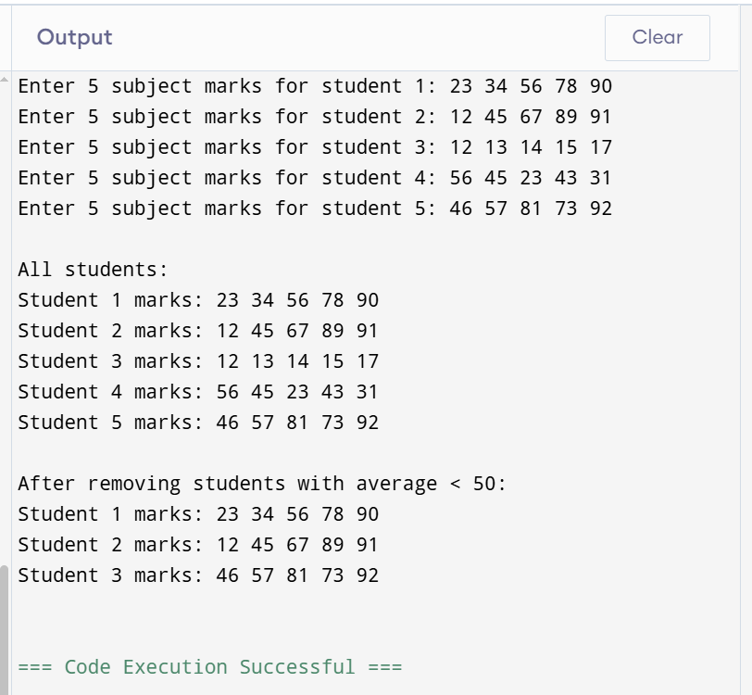

Task 2
#include <iostream>
#include <forward_list>
#include <list>
#include <string>
using namespace std;

int main() {
forward_list<string> normalPatients;
list<string> emergencyPatients;

int totalPatients = 5;
cout << "Enter five patients' names and types!\n";
for (int i = 0; i < totalPatients; i++) {
string name, type;
cout << "\nEnter patient " << i + 1 << " name: ";
getline(cin, name);
cout << "Enter patient " << i + 1 << " type (normal/emergency): ";
getline(cin, type);

if (type == "normal") {
auto it = normalPatients.before_begin();
for (auto &x : normalPatients) ++it;
normalPatients.insert_after(it, name);
}
else if (type == "emergency") {
emergencyPatients.push_back(name);
}
else {
cout << "Invalid type, skipping...\n";
}
}

cout << "\n--- Serving Patients ---\n";
for (int i = 0; i < totalPatients; i++) {

if (!emergencyPatients.empty()) {
cout << "Serving emergency patient: " << emergencyPatients.front() << endl;
emergencyPatients.pop_front();
}
else if (!normalPatients.empty()) {
cout << "Serving normal patient: " << normalPatients.front() << endl;
normalPatients.pop_front();
}

cout << "\nUpdated Queues:\n";

cout << "Emergency Patients: ";
if (emergencyPatients.empty()) {
cout << "None";
} else {
for (auto &p : emergencyPatients) {
cout << p << " ";
}
}

cout << "\nNormal Patients: ";
if (normalPatients.empty()) {
cout << "None";
} else {
for (auto &p : normalPatients) {
cout << p << " ";
}
}

cout << "\n";
}
cout << "\nAll patients have been served.\n";
return 0;
}

OUTPUT:

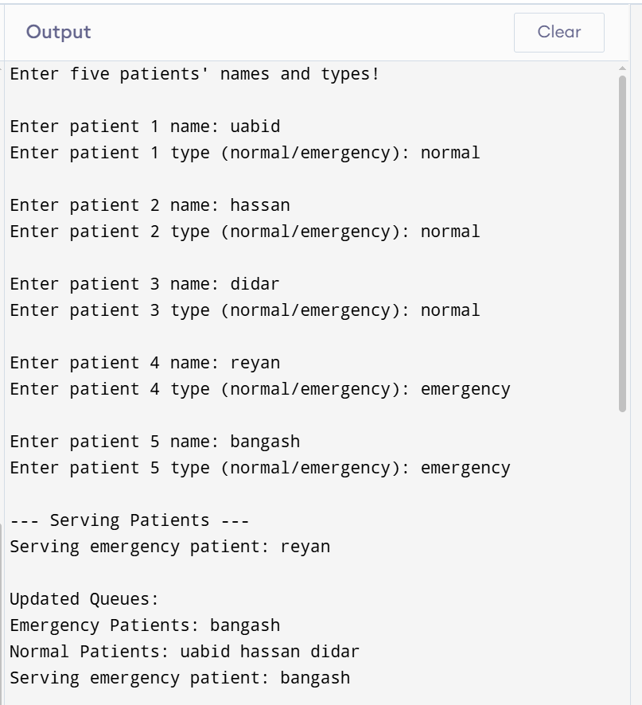
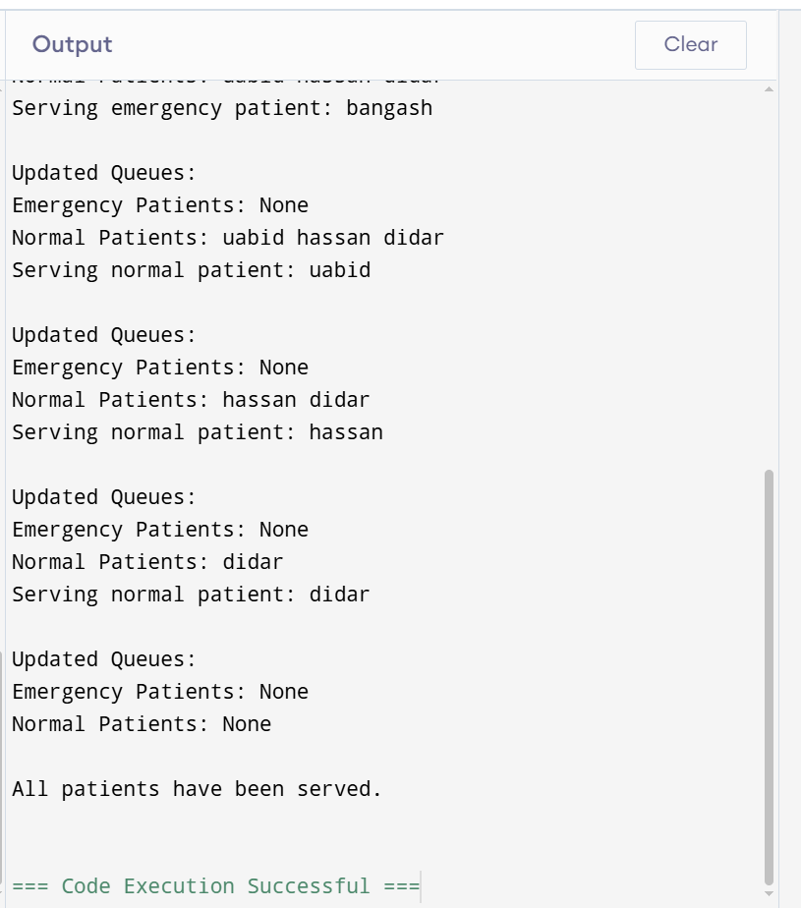

Task3
#include <iostream>
#include <forward_list>
#include <array>
using namespace std;
int main() {
forward_list<array<int,3>> products;
int totalProducts = 5;

cout << "Enter 5 products (ID, Price, Quantity):\n";

for(int i = 0; i < totalProducts; i++) {
int id, price, qty;

cout << "\nProduct " << i+1 << " ID: ";
cin >> id;

cout << "Product " << i+1 << " Price: ";
cin >> price;

cout << "Product " << i+1 << " Quantity: ";
cin >> qty;

array<int,3> p = {id, price, qty};
auto it = products.before_begin();
for (auto &x : products) ++it;
products.insert_after(it, p);
}

cout << "\n--- Inventory Stored Successfully ---\n";
cout << "\nAll Products:\n";
for (auto &p : products) {
cout << "ID: " << p[0]
<< ", Price: " << p[1]
<< ", Quantity: " << p[2] << endl;
}

cout << "\n--- Serving (removing) products one by one ---\n";
for (int i = 0; i < totalProducts; i++) {
if (!products.empty()) {
array<int,3> &p = products.front();
cout << "Removing Product - ID: " << p[0]
<< ", Price: " << p[1]
<< ", Quantity: " << p[2] << endl;

products.pop_front();
}
cout << "\nUpdated Product List:\n";
if (products.empty()) {
cout << "No products left.\n";
} else {
for (auto &p : products) {
cout << "ID: " << p[0]
<< ", Price: " << p[1]
<< ", Quantity: " << p[2] << " ";
}
}
cout << "\n";
}
cout << "\nAll products removed from inventory.\n";
return 0;
}

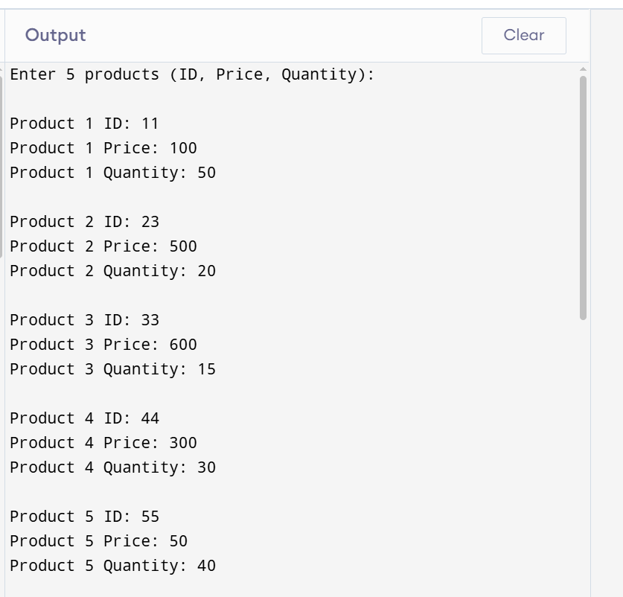
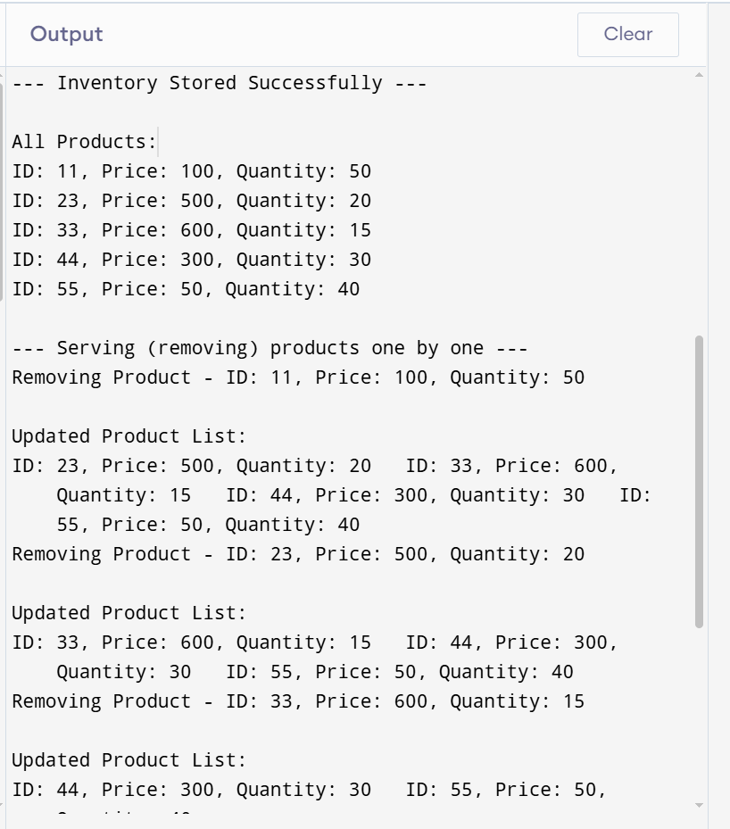
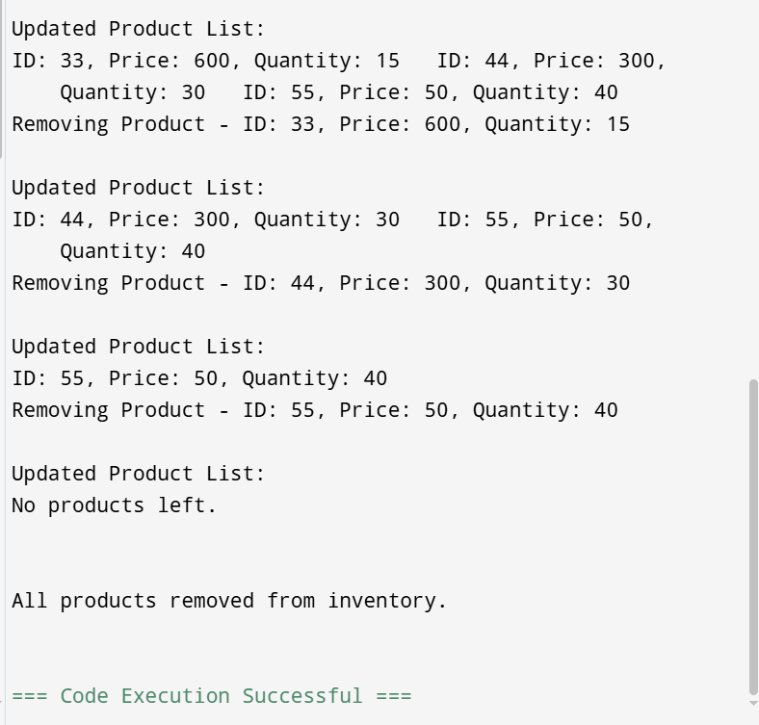
TASK 4
#include <iostream>
#include <list>
#include <forward_list>
#include <string>
#include <algorithm>
using namespace std;
void addRecentlyPlayed(forward_list<string>& recent, const string& song) {
recent.push_front(song);
int count = 0;
auto it = recent.before_begin();

for (auto &x : recent) {
count++;
if (count > 5) break;
++it;
}

if (count > 5) {
recent.erase_after(it);
}
}
int main() {
list<string> playlist;
forward_list<string> recentlyPlayed;
int choice;

do {
cout << "\n--- Music Playlist Menu ---\n";
cout << "1. Add Song to Playlist\n";
cout << "2. Play a Song\n";
cout << "3. Remove a Song from Playlist\n";
cout << "4. Display Playlist\n";
cout << "5. Display Recently Played Songs\n";
cout << "6. Sort Playlist by Title\n";
cout << "0. Exit\n";
cout << "Enter choice: ";
cin >> choice;
cin.ignore();

if (choice == 1) {
string song;
cout << "Enter song title: ";
getline(cin, song);
playlist.push_back(song);
cout << "Song added.\n";
}
else if (choice == 2) {
string song;
cout << "Enter song title to play: ";
getline(cin, song);
auto it = find(playlist.begin(), playlist.end(), song);
if (it != playlist.end()) {
cout << "Playing: " << song << endl;
addRecentlyPlayed(recentlyPlayed, song);
} else {
cout << "Song not found in playlist.\n";
}
}
else if (choice == 3) {
string song;
cout << "Enter song title to remove: ";
getline(cin, song);
playlist.remove(song);
cout << "Song removed (if it existed).\n";
}
else if (choice == 4) {
cout << "\n--- Playlist ---\n";
if (playlist.empty()) cout << "Playlist is empty.\n";
else {
for (auto &s : playlist) {
cout << s << endl;
}
}
}
else if (choice == 5) {
cout << "\n--- Recently Played Songs (Max 5) ---\n";
if (recentlyPlayed.empty()) cout << "No recent songs.\n";
else {
for (auto &s : recentlyPlayed) {
cout << s << endl;
}
}
}
else if (choice == 6) {
playlist.sort();
cout << "Playlist sorted.\n";
}
} while (choice != 0);
cout << "Exiting program.\n";
return 0;
}
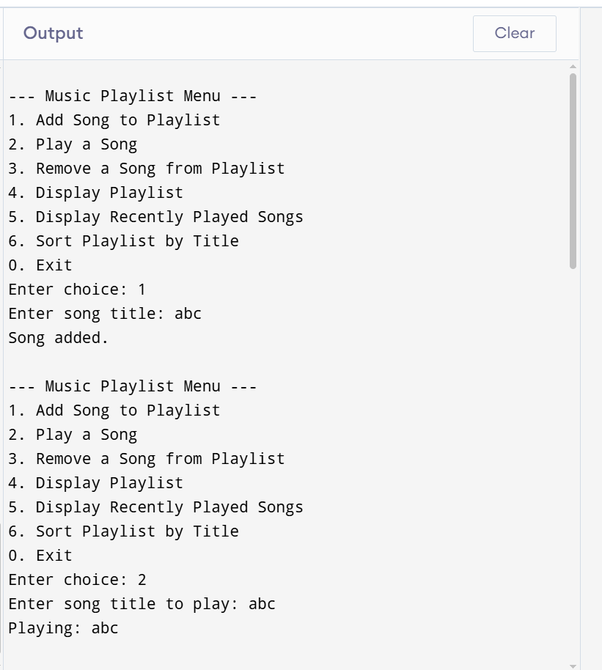
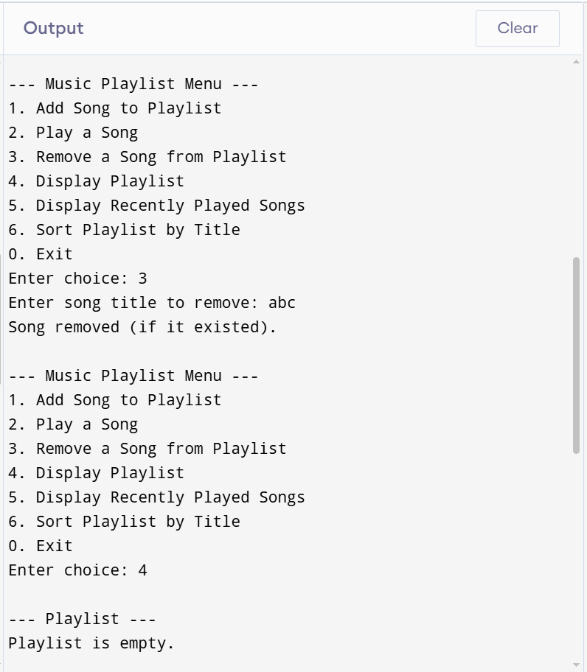
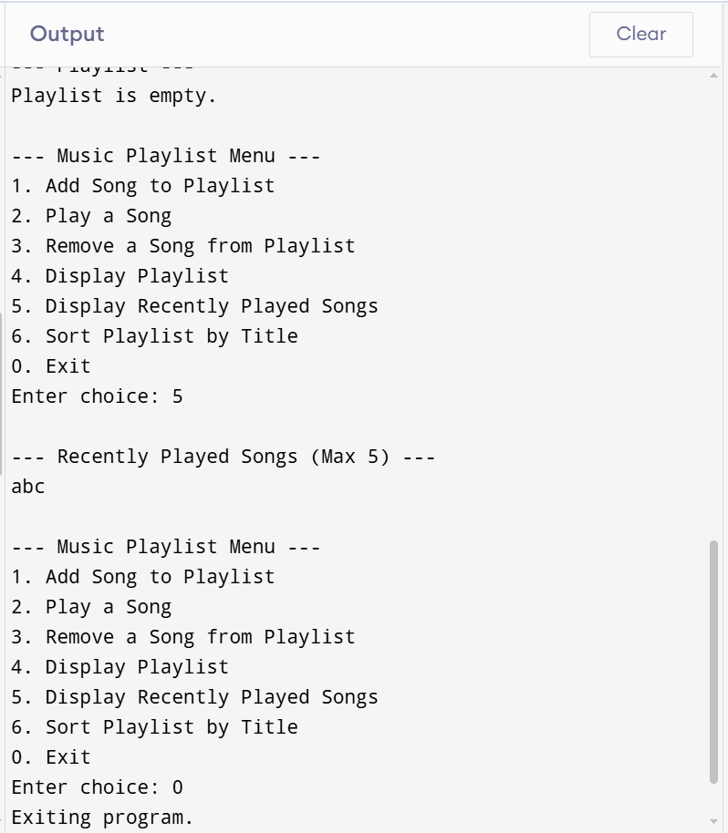
END,,,

